Anomalies:

* double car

B11_003796.jpg

Dlaczego tylko ten jeden?? Ta skala, obiekt i tło to 6 położeń

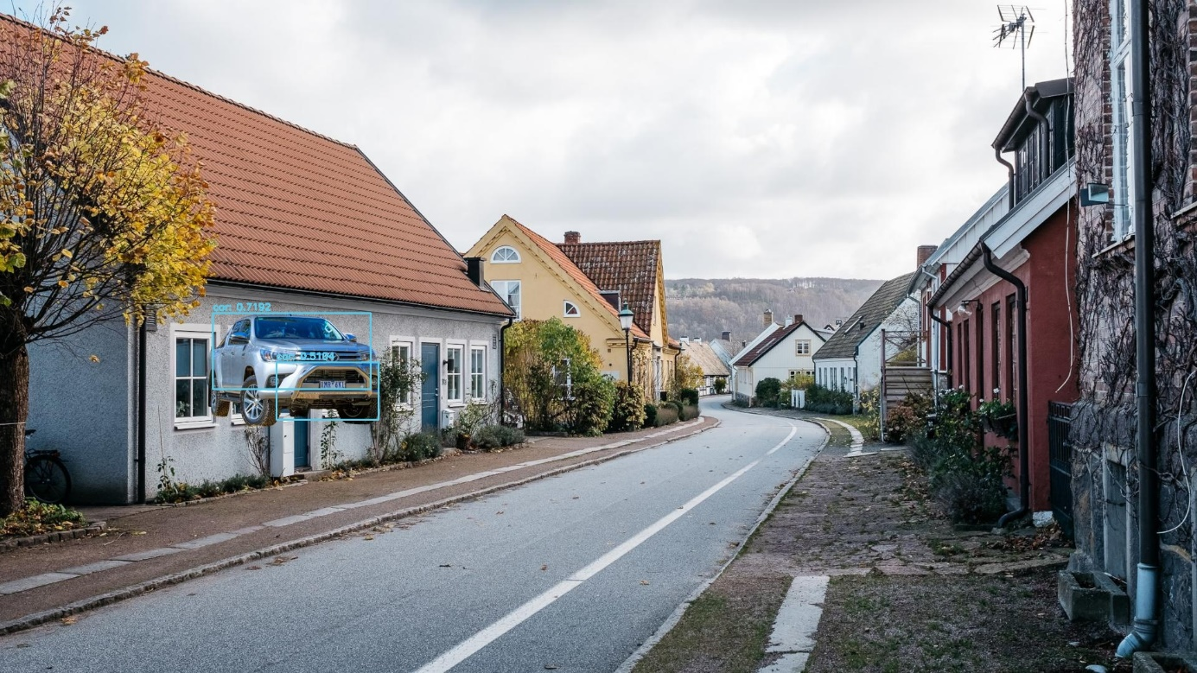

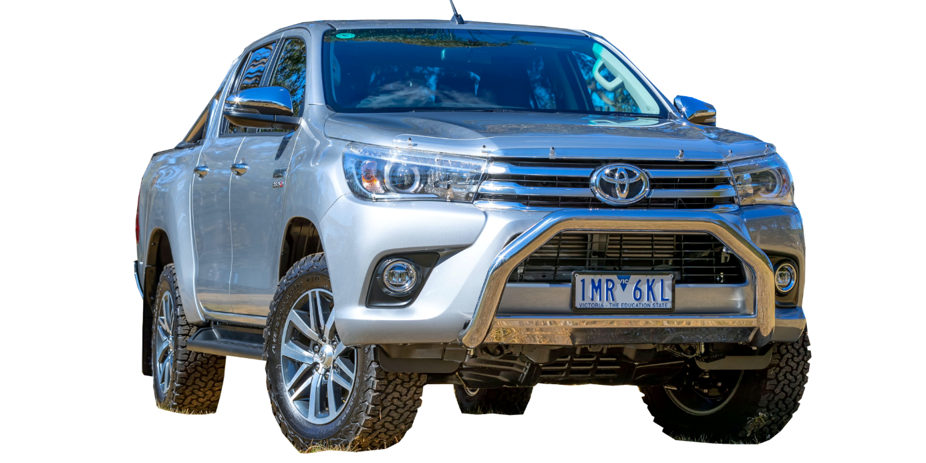

* car with „dog”



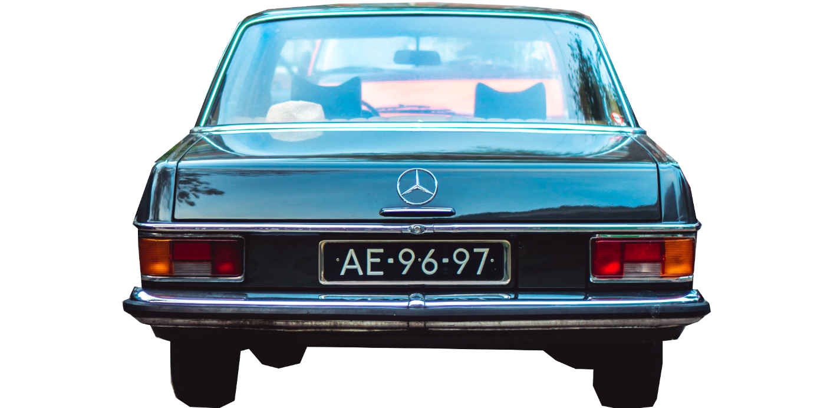

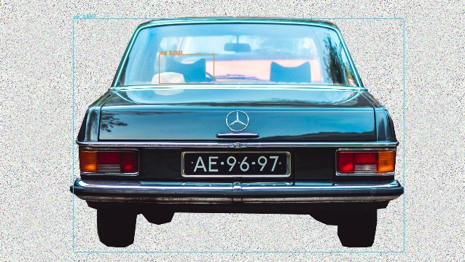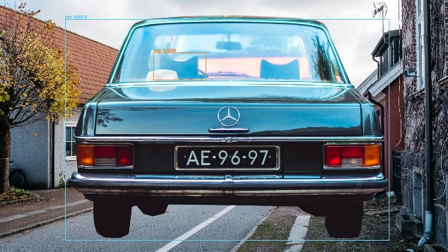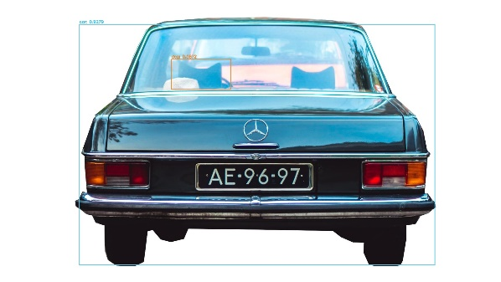

WHY NOT: ??? B14_004125.jpg","B14_004127.jpg

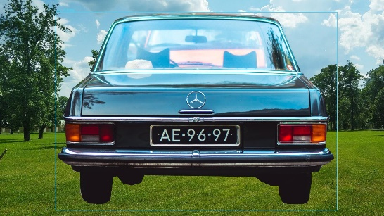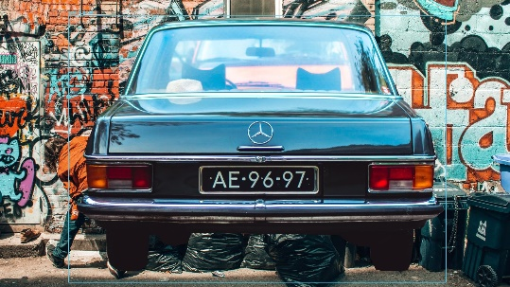

* dog chairs~~~

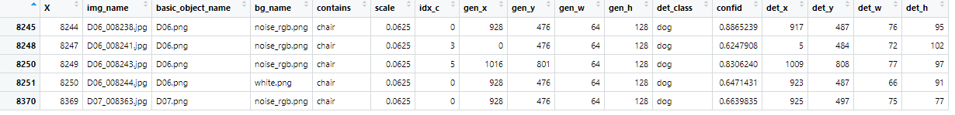

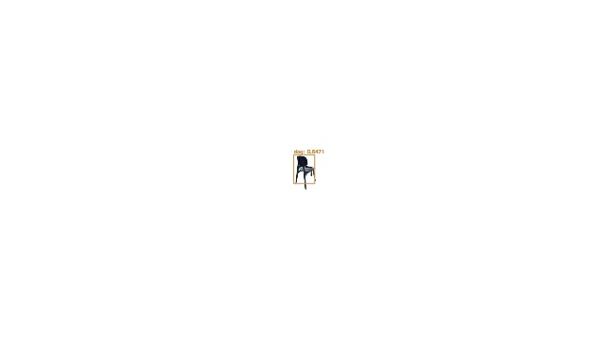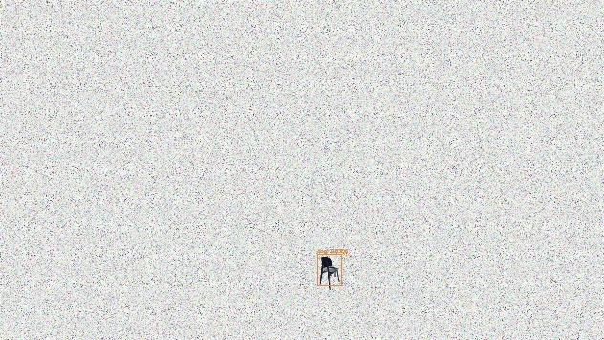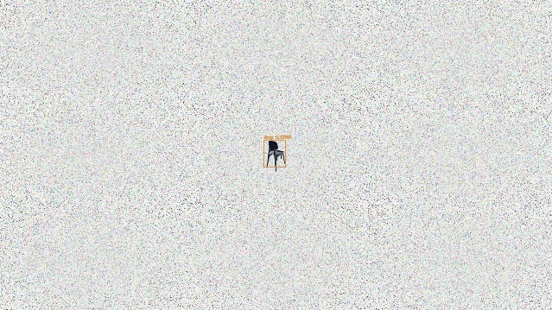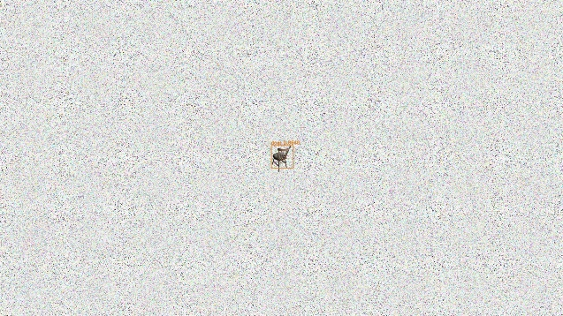

* dog dupli

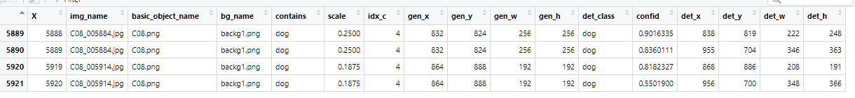

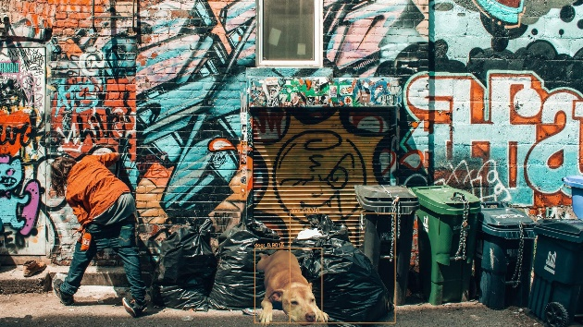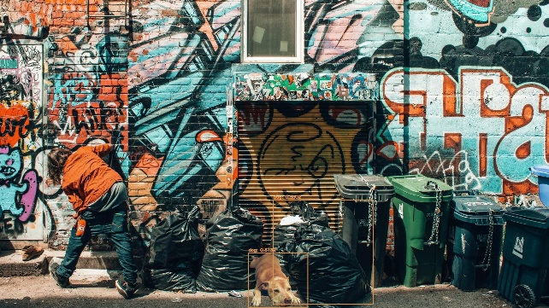

______________

ogółem

car 1450/1049

chair 949/1546

apple 849/1651

dog 730/1768

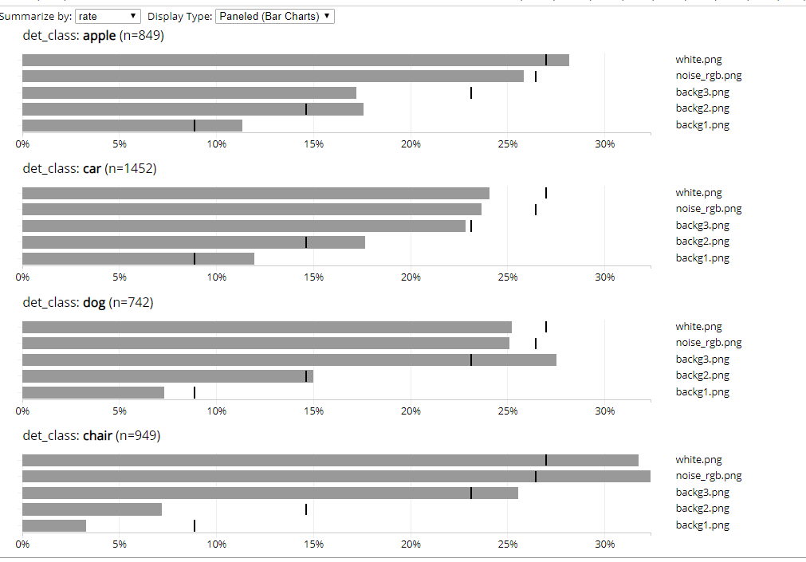

_______________________________

WITHOUT ERRORS

|  |  |  |  |  |  |  |  |  |  |  |  |
| --- | --- | --- | --- | --- | --- | --- | --- | --- | --- | --- | --- |
| 2500 |  | 100 | | 25 | | 18,75 | | 12,5 | | 6,25 | |
| apple | centr | 79 |  | 83 |  | 61 |  | 26 |  | 4 |  |
| TL |  |  | 61 |  | 27 |  | 2 |  |  |  |
| BR |  |  | 66 |  | 45 |  | 2 |  |  |  |
| left |  |  | 60 |  | 36 |  | 5 |  |  |  |
| bottom |  |  | 77 |  | 53 |  | 7 |  |  |  |
| random |  |  | 79 |  | 53 |  | 23 |  |  |  |

środek lub dół, gdy za duży słabiej sobie radzi

|  |  |  |  |  |  |  |  |  |  |  |  |
| --- | --- | --- | --- | --- | --- | --- | --- | --- | --- | --- | --- |
| 2499 |  | 100 | | 25 | | 18,75 | | 12,5 | | 6,25 | |
| car | centr | 71 |  | 73 |  | 76 |  | 58 |  | 23 |  |
| TL |  |  | 77 |  | 69 |  | 53 |  | 14 |  |
| BR |  |  | 91 |  | 85 |  | 60 |  | 8 |  |
| left |  |  | 66 |  | 67 |  | 53 |  | 20 |  |
| bottom |  |  | 91 |  | 80 |  | 61 |  | 11 |  |
| random |  |  | 80 |  | 76 | 23? | 66 |  | 21 |  |

dolna, dolna prawa część obrazka, gdy za duży słabiej sobie radzi (14k próbek w bazie, ale lepiej sobie radzi niż krzesła)

|  |  |  |  |  |  |  |  |  |  |  |  |
| --- | --- | --- | --- | --- | --- | --- | --- | --- | --- | --- | --- |
| Nie odjęłam 5 w chair chair |  | 100 | | 25 | | 18,75 | | 12,5 | | 6,25 | |
| chair | centr | 70 |  | 65 |  | 48 |  | 25 |  | 3 | 94 |
| TL |  |  | 46 |  | 47 |  | 19 |  |  |  |
| BR |  |  | 67 |  | 61 |  | 32 |  |  |  |
| left |  |  | 55 |  | 50 |  | 28 |  | 4 | 95 |
| bottom |  |  | 74 |  | 71 |  | 41 |  |  |  |
| random |  |  | 62 |  | 53 |  | 25 |  | 3 | 96 |

raczej dół, najwięcej próbek w bazie (ok 15k)

|  |  |  |  |  |  |  |  |  |  |  |  |
| --- | --- | --- | --- | --- | --- | --- | --- | --- | --- | --- | --- |
| 2498 |  | 100 | | 25 | | 18,75 | | 12,5 | | 6,25 | |
| dog | centr | 95 |  | 45 |  | 31 |  | 14 |  | 2 |  |
| TL |  |  | 37 |  | 21 |  | 2 |  |  |  |
| BR |  |  | 63 |  | 43 |  | 4 |  |  |  |
| left |  |  | 48 |  | 26 |  | 5 |  |  |  |
| bottom |  |  | 80 | 19 | 65 | 34 | 28 |  |  |  |
| random |  |  | 55 |  | 43 |  | 20 |  | 3 |  |

dół obrazka

APPLE

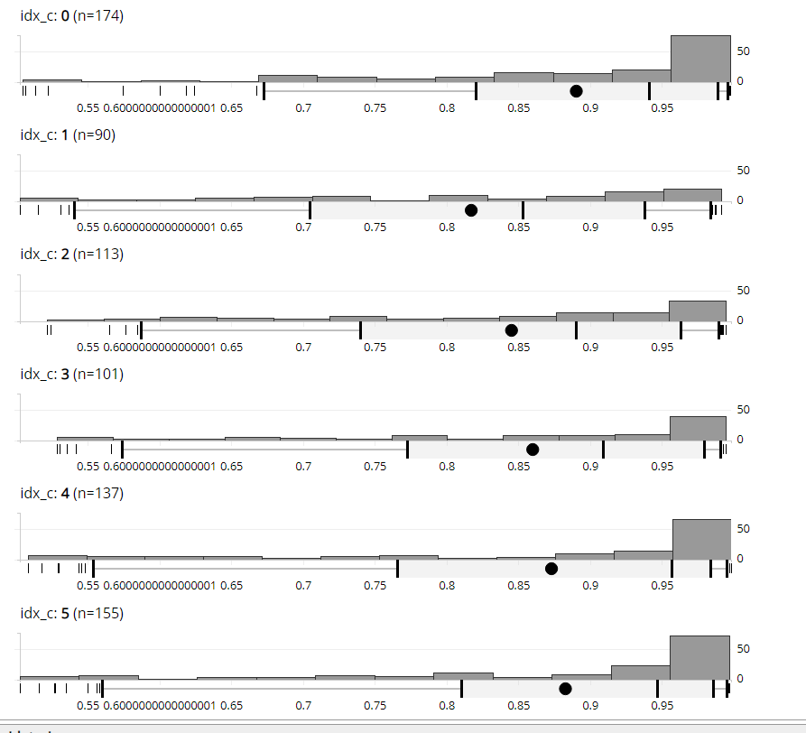

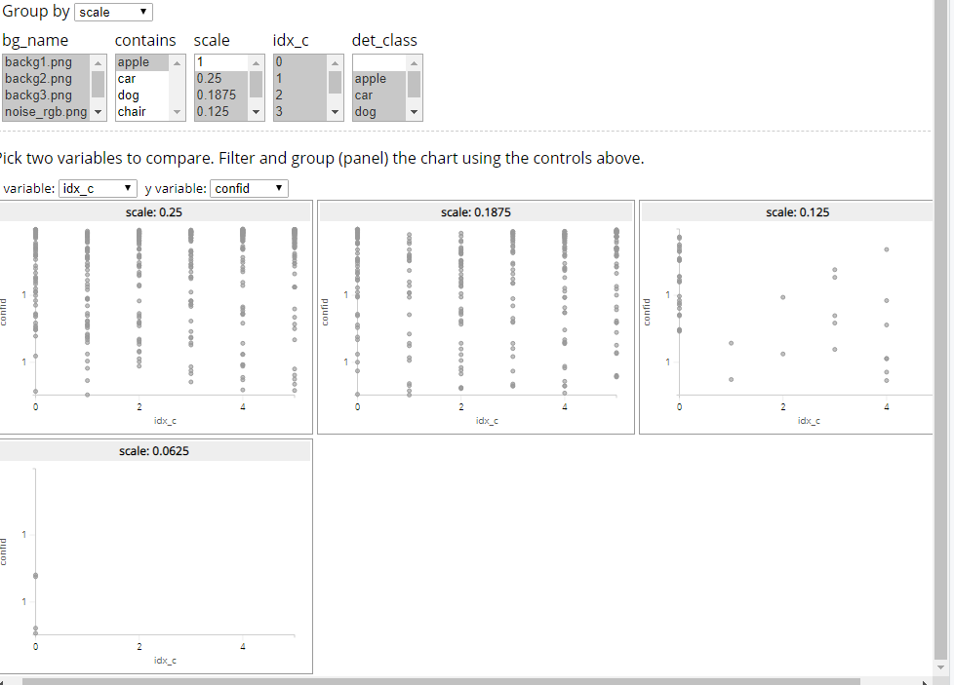

CAR

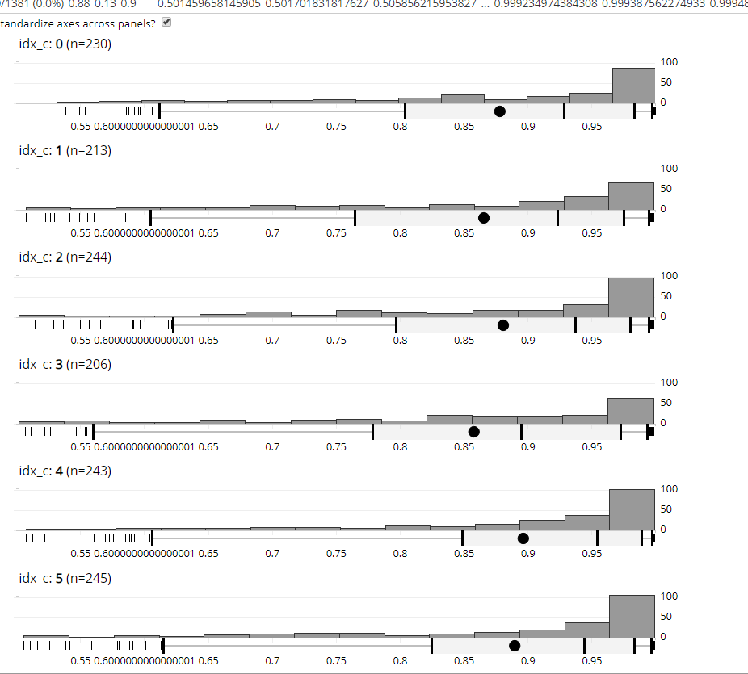

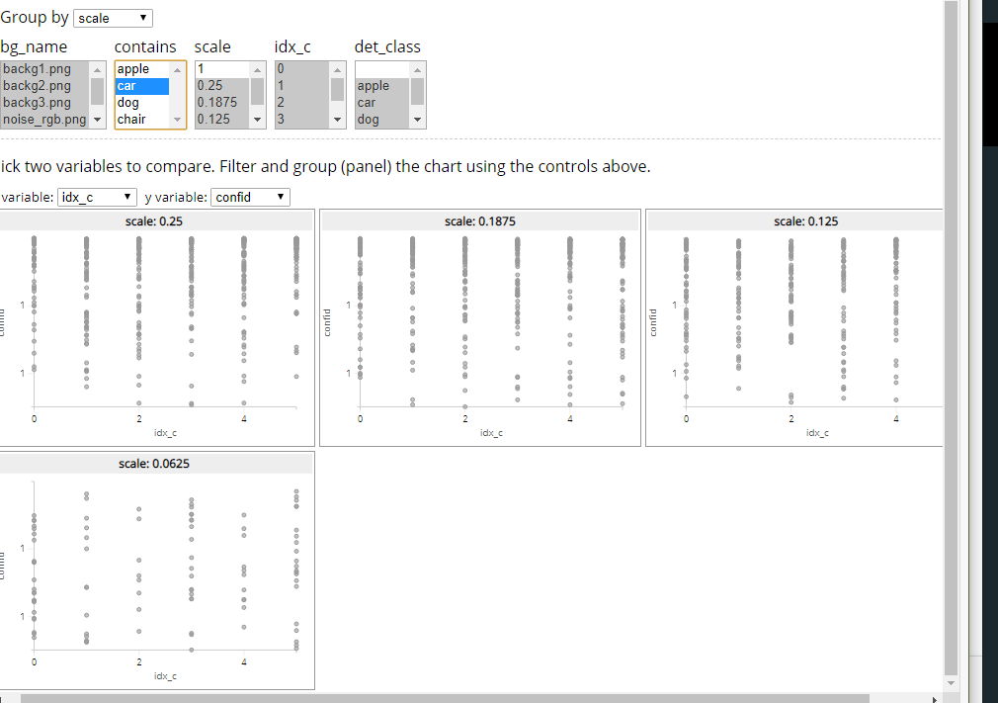

DOG

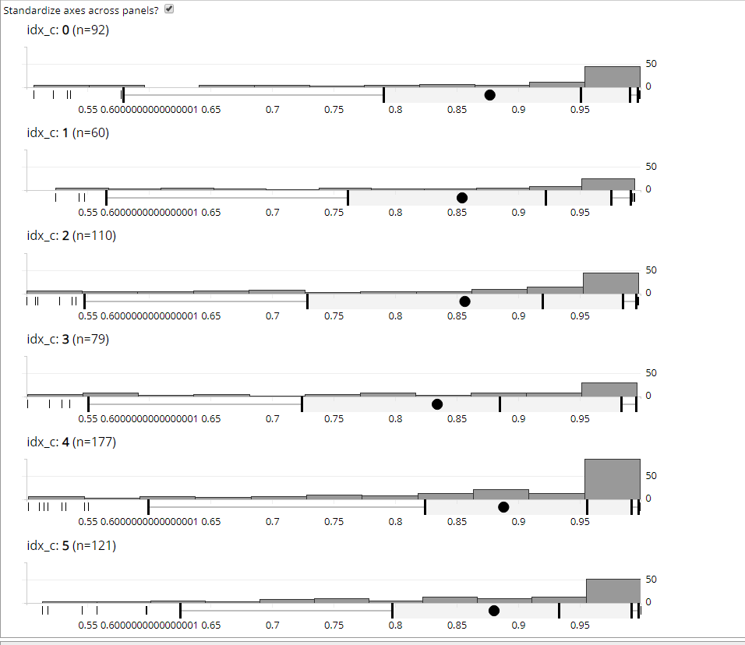

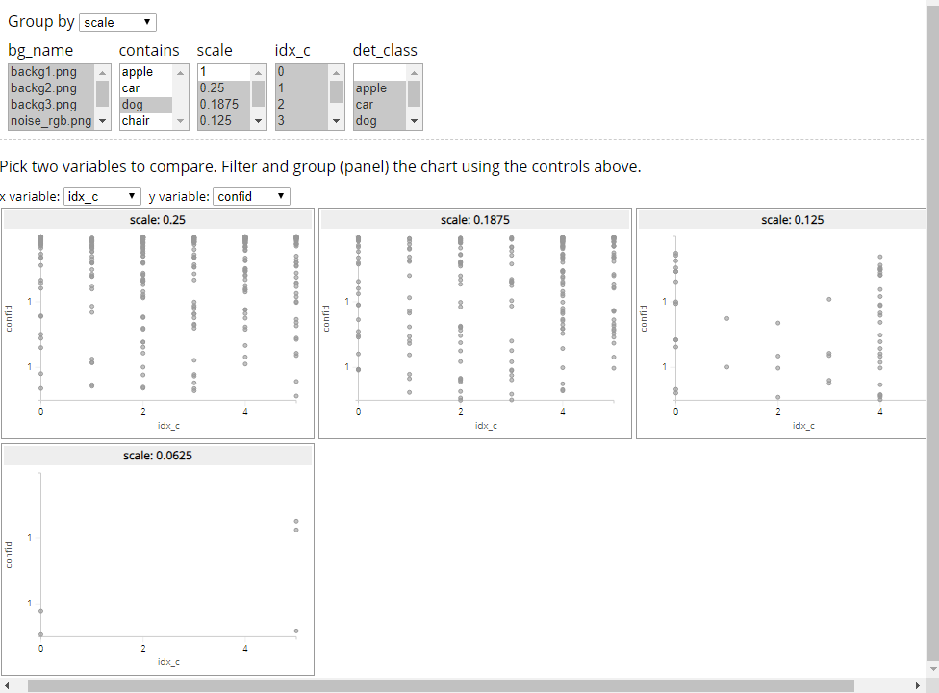

CHAIR

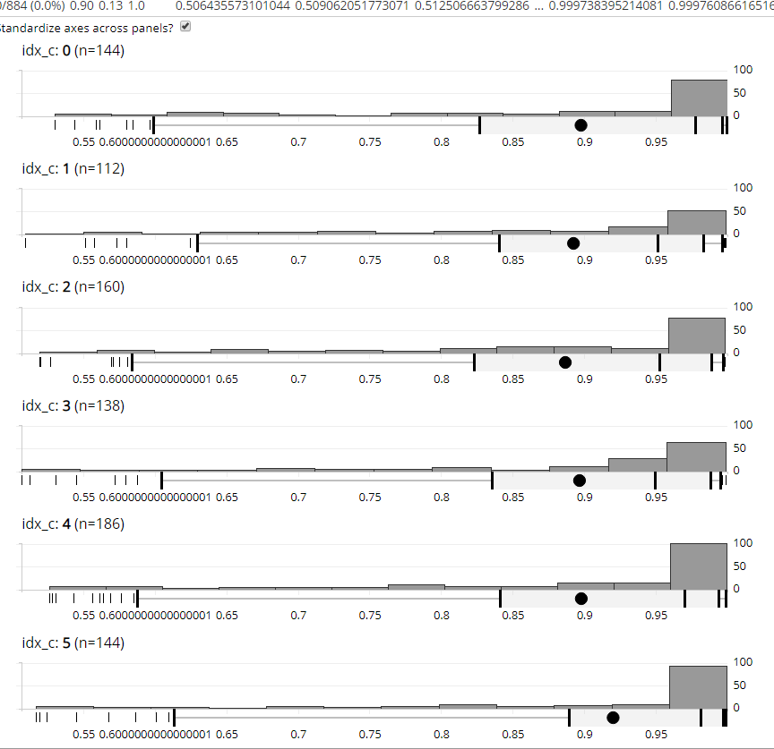

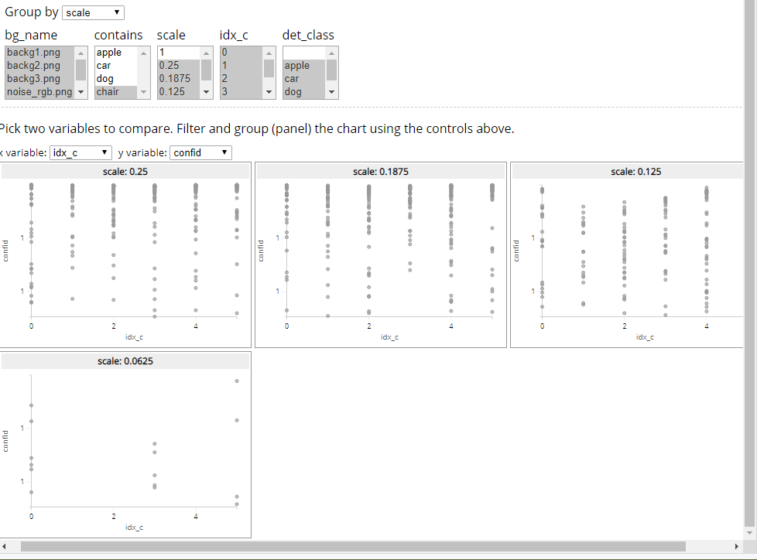

* usefull commands
  + znajdźduplikaty
    - z <- data.frame(table(dog_all$img_name))
    - z[z$Freq>1,]